1

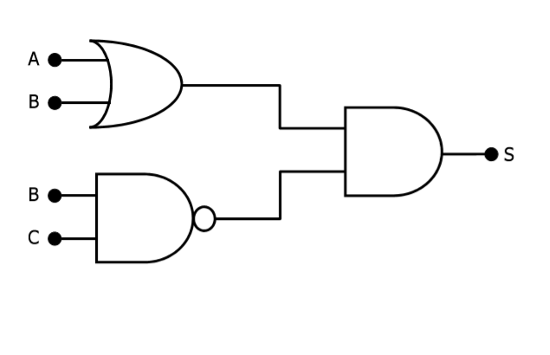

|  |  |  |  |  |  |  |  |  |
| --- | --- | --- | --- | --- | --- | --- | --- | --- |
| A | B | S1=A+B | B | C | S2=B.C | S1 | S2 | S |
| 0 | 0 | 0 | 0 | 0 | 1 | 0 | 1 | 0 |
| 0 | 1 | 0 | 0 | 1 | 1 | 0 | 1 | 0 |
| 0 | 0 | 0 | 0 | 0 | 1 | 0 | 1 | 0 |
| 0 | 1 | 0 | 0 | 1 | 1 | 0 | 1 | 0 |
| 0 | 0 | 0 | 0 | 0 | 1 | 0 | 1 | 0 |
| 0 | 1 | 0 | 0 | 1 | 1 | 0 | 1 | 0 |
| 0 | 0 | 0 | 0 | 0 | 1 | 0 | 1 | 0 |
| 0 | 1 | 0 | 0 | 1 | 1 | 0 | 1 | 0 |
| 1 | 1 | 1 | 1 | 0 | 1 | 1 | 1 | 1 |
| 1 | 0 | 0 | 1 | 1 | 0 | 0 | 0 | 0 |
| 1 | 1 | 1 | 1 | 0 | 1 | 1 | 1 | 1 |
| 1 | 0 | 0 | 1 | 1 | 0 | 0 | 0 | 0 |
| 1 | 1 | 1 | 1 | 0 | 1 | 1 | 1 | 1 |
| 1 | 0 | 0 | 1 | 1 | 0 | 0 | 0 | 0 |
| 1 | 1 | 1 | 1 | 0 | 1 | 1 | 1 | 1 |
| 1 | 0 | 0 | 1 | 1 | 0 | 0 | 0 | 0 |

2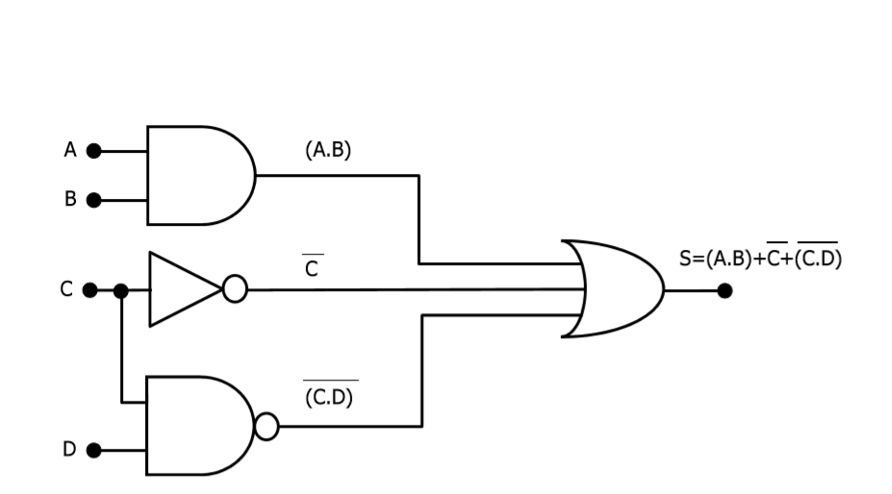

|  |  |  |  |  |  |  |  |  |  |  |  |
| --- | --- | --- | --- | --- | --- | --- | --- | --- | --- | --- | --- |
| A | B | S1=A.B | C | S=C’ | C | D | S2=C.D’ | S1 | S2 | S3 | S |
| 0 | 0 | 0 | 0 | 1 | 0 | 0 | 1 | 0 | 1 | 1 | 1 |
| 0 | 1 | 0 | 0 | 1 | 0 | 1 | 1 | 0 | 1 | 1 | 1 |
| 0 | 0 | 0 | 0 | 1 | 0 | 0 | 1 | 0 | 1 | 1 | 1 |
| 0 | 1 | 0 | 0 | 1 | 0 | 1 | 1 | 0 | 1 | 1 | 1 |
| 0 | 0 | 0 | 0 | 1 | 0 | 0 | 1 | 0 | 1 | 1 | 1 |
| 0 | 1 | 0 | 0 | 1 | 0 | 1 | 1 | 0 | 1 | 1 | 1 |
| 0 | 0 | 0 | 0 | 1 | 0 | 0 | 1 | 0 | 1 | 1 | 1 |
| 0 | 1 | 0 | 0 | 1 | 0 | 1 | 1 | 0 | 1 | 1 | 1 |
| 1 | 0 | 0 | 1 | 0 | 1 | 0 | 1 | 0 | 1 | 0 | 1 |
| 1 | 1 | 1 | 1 | 0 | 1 | 1 | 0 | 1 | 0 | 0 | 1 |
| 1 | 0 | 0 | 1 | 0 | 1 | 0 | 1 | 0 | 1 | 0 | 1 |
| 1 | 1 | 1 | 1 | 0 | 1 | 1 | 0 | 1 | 0 | 0 | 1 |
| 1 | 0 | 0 | 1 | 0 | 1 | 0 | 1 | 0 | 1 | 0 | 1 |
| 1 | 1 | 1 | 1 | 0 | 1 | 1 | 0 | 1 | 0 | 0 | 1 |
| 1 | 0 | 0 | 1 | 0 | 1 | 0 | 1 | 0 | 1 | 0 | 1 |
| 1 | 1 | 1 | 1 | 0 | 1 | 1 | 0 | 1 | 0 | 0 | 1 |

3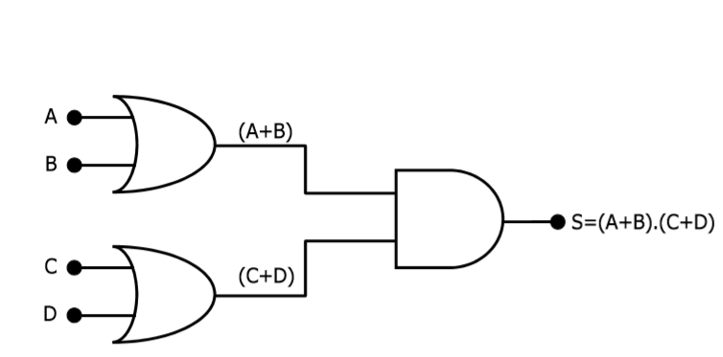

|  |  |  |  |  |  |  |  |  |
| --- | --- | --- | --- | --- | --- | --- | --- | --- |
| A | B | S1=A+B | C | D | S2=C+D | S1 | S2 | S |
| 0 | 0 | 0 | 0 | 0 | 0 | 0 | 0 | 0 |
| 0 | 1 | 1 | 0 | 1 | 1 | 1 | 1 | 1 |
| 0 | 0 | 0 | 0 | 0 | 0 | 0 | 0 | 0 |
| 0 | 1 | 1 | 0 | 1 | 1 | 1 | 1 | 1 |
| 0 | 0 | 0 | 0 | 0 | 0 | 0 | 0 | 0 |
| 0 | 1 | 1 | 0 | 1 | 1 | 1 | 1 | 1 |
| 0 | 0 | 0 | 0 | 0 | 0 | 0 | 0 | 0 |
| 0 | 1 | 1 | 0 | 1 | 1 | 1 | 1 | 1 |
| 1 | 0 | 1 | 1 | 0 | 1 | 1 | 1 | 1 |
| 1 | 1 | 1 | 1 | 1 | 1 | 1 | 1 | 1 |
| 1 | 0 | 1 | 1 | 0 | 1 | 1 | 1 | 1 |
| 1 | 1 | 1 | 1 | 1 | 1 | 1 | 1 | 1 |
| 1 | 0 | 1 | 1 | 0 | 1 | 1 | 1 | 1 |
| 1 | 1 | 1 | 1 | 1 | 1 | 1 | 1 | 1 |
| 1 | 0 | 1 | 1 | 0 | 1 | 1 | 1 | 1 |
| 1 | 1 | 1 | 1 | 1 | 1 | 1 | 1 | 1 |

4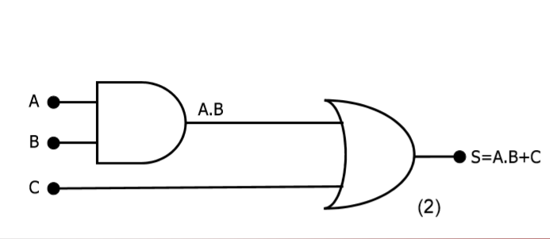

|  |  |  |  |  |  |
| --- | --- | --- | --- | --- | --- |
| A | B | S=A.B | C | S1 | S |
| 0 | 0 | 0 | 0 | 0 | 0 |
| 0 | 1 | 0 | 0 | 0 | 0 |
| 0 | 0 | 0 | 0 | 0 | 0 |
| 0 | 1 | 0 | 0 | 0 | 0 |
| 1 | 0 | 0 | 1 | 0 | 1 |
| 1 | 1 | 1 | 1 | 1 | 1 |
| 1 | 0 | 0 | 1 | 0 | 1 |
| 1 | 1 | 1 | 1 | 1 | 1 |

5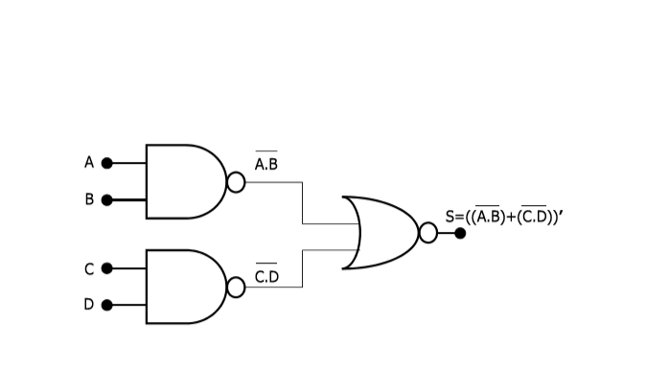

|  |  |  |  |  |  |  |  |  |
| --- | --- | --- | --- | --- | --- | --- | --- | --- |
| A | B | S=A.B’ | C | D | S=C.D’ | S1 | S2 | S |
| 0 | 0 | 1 | 0 | 0 | 1 | 1 | 1 | 0 |
| 0 | 1 | 1 | 0 | 1 | 1 | 1 | 1 | 0 |
| 0 | 0 | 1 | 0 | 0 | 1 | 1 | 1 | 0 |
| 0 | 1 | 1 | 0 | 1 | 1 | 1 | 1 | 0 |
| 0 | 0 | 1 | 0 | 0 | 1 | 1 | 1 | 0 |
| 0 | 1 | 1 | 0 | 1 | 1 | 1 | 1 | 0 |
| 0 | 0 | 1 | 0 | 0 | 1 | 1 | 1 | 0 |
| 0 | 1 | 1 | 0 | 1 | 1 | 1 | 1 | 0 |
| 1 | 0 | 1 | 1 | 0 | 1 | 1 | 1 | 0 |
| 1 | 1 | 0 | 1 | 1 | 0 | 0 | 0 | 1 |
| 1 | 0 | 1 | 1 | 0 | 1 | 1 | 1 | 0 |
| 1 | 1 | 0 | 1 | 1 | 0 | 0 | 0 | 1 |
| 1 | 0 | 1 | 1 | 0 | 1 | 1 | 1 | 0 |
| 1 | 1 | 0 | 1 | 1 | 0 | 0 | 0 | 1 |
| 1 | 0 | 1 | 1 | 0 | 1 | 1 | 1 | 0 |
| 1 | 1 | 0 | 1 | 1 | 0 | 0 | 0 | 1 |

6

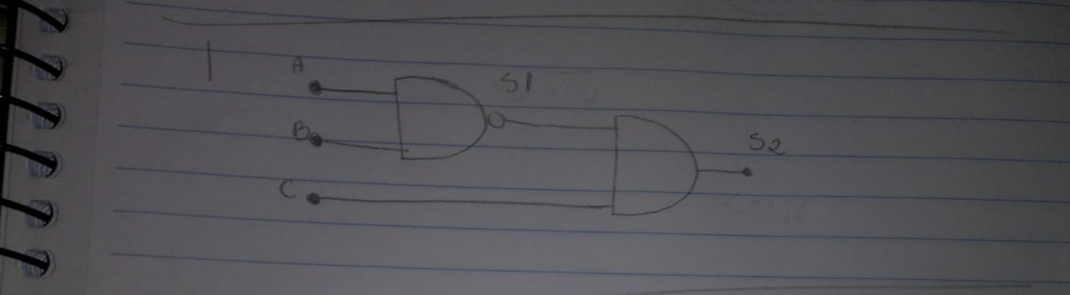

|  |  |  |  |  |
| --- | --- | --- | --- | --- |
| A | B | S1 | C | S2 |
| 1 | 1 | 0 | 1 | 0 |
| 1 | 1 | 0 | 0 | 0 |
| 1 | 0 | 1 | 1 | 1 |
| 1 | 0 | 1 | 0 | 0 |
| 0 | 1 | 1 | 0 | 0 |
| 0 | 1 | 1 | 1 | 1 |
| 0 | 0 | 1 | 1 | 1 |
| 0 | 0 | 1 | 0 | 0 |

7

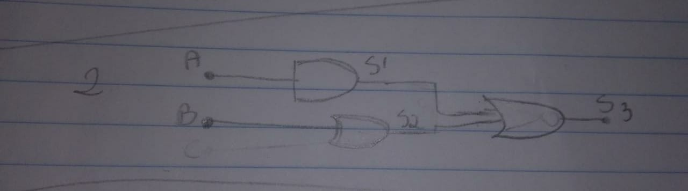

|  |  |  |  |  |
| --- | --- | --- | --- | --- |
| A | S1 | B | S2 | S3 |
| 1 | 1 | 1 | 1 | 1 |
| 1 | 1 | 0 | 0 | 1 |
| 0 | 0 | 1 | 1 | 1 |
| 0 | 0 | 0 | 0 | 0 |

8

3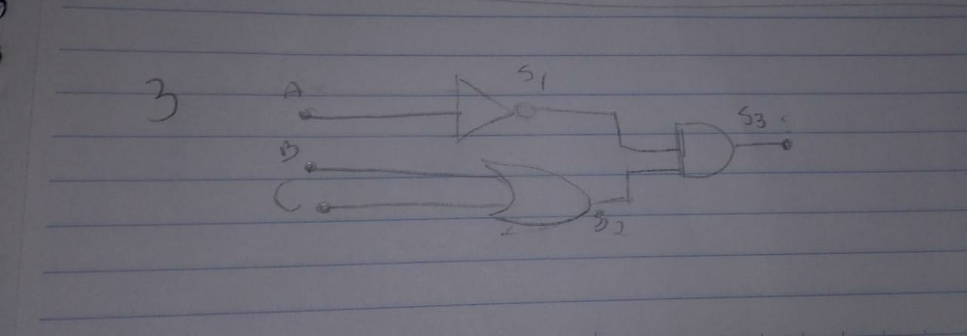

|  |  |  |  |  |  |
| --- | --- | --- | --- | --- | --- |
| A | S1 | B | C | S2 | S3 |
| 1 | 0 | 1 | 1 | 1 | 0 |
| 1 | 0 | 1 | 0 | 1 | 0 |
| 1 | 0 | 0 | 0 | 0 | 0 |
| 0 | 1 | 0 | 0 | 0 | 0 |
| 0 | 1 | 1 | 0 | 1 | 1 |
| 0 | 1 | 1 | 1 | 1 | 1 |
| 1 | 0 | 0 | 1 | 1 | 1 |
| 0 | 1 | 1 | 0 | 1 | 1 |

9

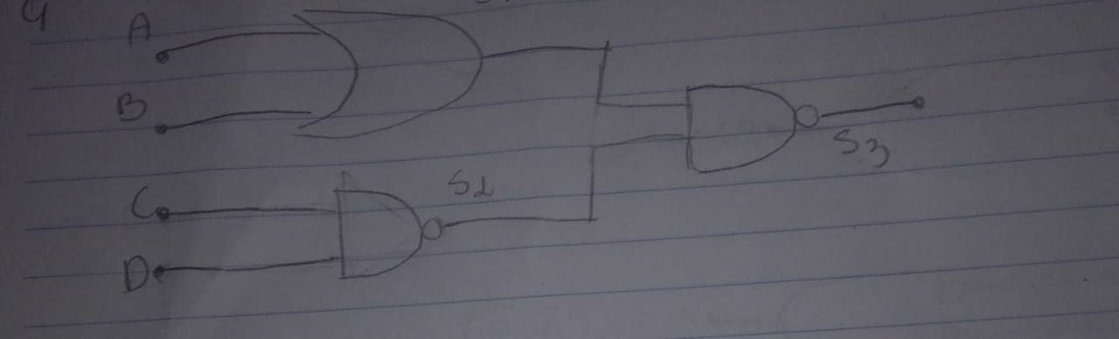

|  |  |  |  |  |  |  |
| --- | --- | --- | --- | --- | --- | --- |
| A | B | S1 | C | D | S2 | S3 |
| 1 | 1 | 1 | 1 | 1 | 0 | 0 |
| 1 | 1 | 1 | 1 | 0 | 1 | 0 |
| 1 | 1 | 1 | 0 | 1 | 1 | 0 |
| 1 | 1 | 1 | 0 | 0 | 1 | 0 |
| 1 | 0 | 1 | 1 | 1 | 0 | 0 |
| 1 | 0 | 1 | 1 | 0 | 1 | 0 |
| 1 | 0 | 1 | 0 | 1 | 1 | 0 |
| 1 | 0 | 1 | 0 | 0 | 1 | 0 |
| 0 | 1 | 1 | 1 | 1 | 0 | 0 |
| 0 | 1 | 1 | 0 | 1 | 1 | 0 |
| 0 | 1 | 1 | 1 | 0 | 1 | 0 |
| 0 | 1 | 1 | 0 | 0 | 1 | 0 |
| 0 | 0 | 0 | 1 | 1 | 0 | 1 |
| 0 | 0 | 0 | 1 | 0 | 1 | 0 |
| 0 | 0 | 0 | 0 | 1 | 1 | 0 |
| 0 | 0 | 0 | 0 | 0 | 1 | 0 |

10

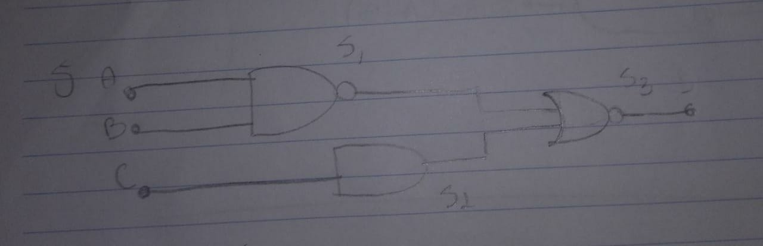

|  |  |  |  |  |  |
| --- | --- | --- | --- | --- | --- |
| A | B | S1 | C | S2 | S3 |
| 1 | 1 | 0 | 1 | 1 | 0 |
| 1 | 1 | 0 | 0 | 0 | 1 |
| 1 | 0 | 1 | 1 | 1 | 0 |
| 1 | 0 | 1 | 0 | 0 | 0 |
| 0 | 1 | 1 | 1 | 1 | 0 |
| 0 | 1 | 1 | 0 | 0 | 0 |
| 0 | 0 | 0 | 1 | 1 | 0 |
| 0 | 0 | 0 | 0 | 0 | 1 |